add Jenkins job details for aspen pipeline. like we have four streams
stream1 - DEV01, TEST01, TT01
stream2 - DEV02, TEST02, TT02, REG, PERF, TRANING-DEV01
stream3 - DEV03, TEST03, TT03, SIT
stream4 - DEV04, TEST04, TT04

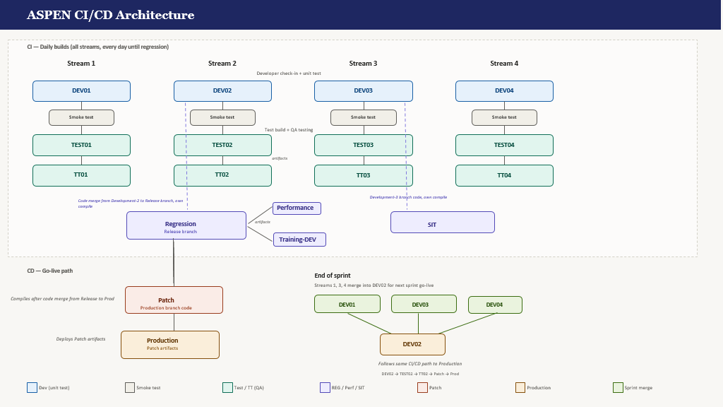

Jenkins Job Details
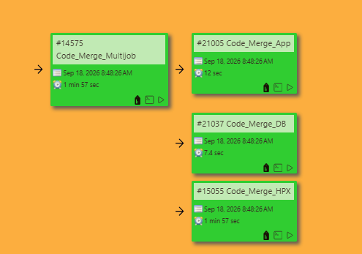

These job needs to be completed to merge your feature branch code into main Development branch. If you get any conflict or issue here you have to resolve for your branch.

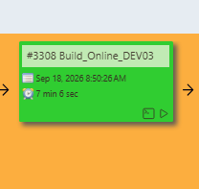
This job complies the code after merge so if you get any compilation error on this job you must check like in which file you are getting compilation error.

Aspen+ Jenkins jobs.
- Jenkins Jobs
Jenkins is a powerful open-source automation server used for continuous integration and continuous delivery (CI/CD) pipelines. It automates build jobs to compile and package code, deploy jobs to handle environment-specific deployments, and merge jobs to integrate changes from one environment to the next. This automation reduces manual intervention, minimizes errors, and accelerates the delivery of high-quality software. There are two jenkins servers, one for non-production and one for production. Below are all the jobs from one non-production environment.
- Front End Services
- UI LIFT Build: http://172.20.252.53:8080/view/test2_build_deploy/job/test2-internal-portal-UI-Build-LIFT/
- UI Deploy: http://172.20.252.53:8080/view/test2_build_deploy/job/test2-internal-portal-UI-Deploy/


Figure 17: Front Service Jenkins Jobs
- Backend Services
- ASPEN API Build: http://172.20.252.53:8080/view/test2_build_deploy/job/test2-internal-portal-aspen-api-Build/
- ASPEN API Deploy: http://172.20.252.53:8080/view/test2_build_deploy/job/test2-internal-portal-aspen-api-Deploy/
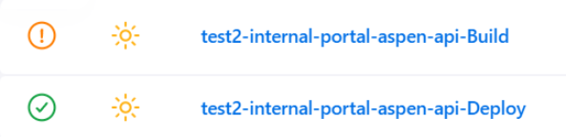
Figure 18: Backend Service Jenkins Jobs
- Modules Build: http://172.20.252.53:8080/view/test2_build_deploy/job/test2-internal-portal-modules-Build/


Figure 19: Modules Build Jenkins Job
- Core Deploy: http://172.20.252.53:8080/view/test2_build_deploy/job/test2-internal-portal-core-Deploy/


Figure 20: Core Deployment Jenkins Job
- Workload Deploy: http://172.20.252.53:8080/view/test2_build_deploy/job/test2-internal-portal-Workload-Deploy/
Figure 21: Workload Deployment Jenkins Job
- Merge Jobs:
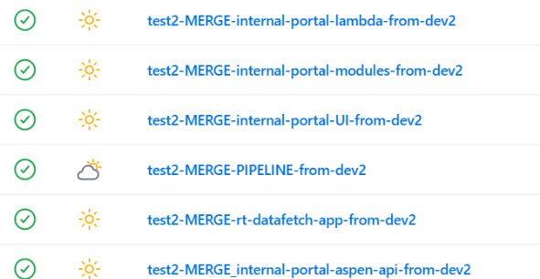
Figure 22: Merge Jenkins Jobs
- OpCon Batch Service: http://172.20.252.53:8080/view/test2_build_deploy/job/test2-opcon-batch-service/

Figure 23: OpCon Batch Service Jenkins Job
- Connect Change Deploy: http://172.20.252.53:8080/view/test2_build_deploy/job/test2_Amazon_Connect_Change_Deploy/

Figure 24: Connect Change Deployment Jenkins Job
- ALB Changes: http://172.20.252.53:8080/view/test2_build_deploy/job/test2_Apply_ALB_Changes/


Figure 25: ALB Changes Jenkins Job
- Lambda Deploy:
http://172.20.252.53:8080/view/test2_build_deploy/job/test2_internal_portal_lambda_Deploy/


Figure 26: Lambda Deployment Jenkins Job

